TEJASWINI DURGE

***tejaswini.22210270@viit.ac.in***

# PROFILE

Pursuing my BTech in IT from VIIT, Pune.

SCI-Tech winners and sport enthusiast. KHO KHO winners in sport fest. Tech Enthusiast and tech savvy.

# CONTACT ME

123-456-7890

[tejaswini.22210270@viit.ac.in](mailto:tejaswini.22210270@viit.ac.in)

Kondhwa, BK, Pune

# EDUCATION

|  |  |  |
| --- | --- | --- |
| *Education* | *FROM* | *PERC/ GPA* |
| *SSC* | *new English school, shirur* | *91.80* |
| *HSC* | *Vidyadham jr college of science* | *80* |
| *FY* | *VIIT* | *8.86* |
| *SY* | *VIIT* | *8.81* |

# SKILLS

1. full stack Web Development2. Figma, Canva3. C++, Java4. Data Structures5. Augmented reality and virtual reality.

# ACADEMIC PROJECT

Car Connect, Telegram Bot.

Mobile phone detector, Memory, Decoder hackathon- TCG, ClubHub website

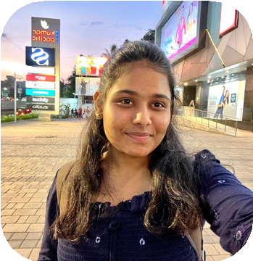

# WORK EXPERIENCE

Trainee at Katalyst India.

joint documentation head at ITSF. virtual internship at CodSoft, virtual internship from AICTE.